Contents

Dia 1. 3

Backup incremental. 3

Full Backup. 3

SELECT * FROM PACIENTE LIMIT 20; 3

SELECT * FROM PACIENTE ORDER BY idPaciente DESC LIMIT 20; 3

SELECT count(*) FROM PACIENTE; 4

Día 2. 4

Backup Incremental. 4

Full Backup. 4

SELECT * FROM HABITACION LIMIT 20; 4

SELECT * FROM PACIENTE LIMIT 20; 4

SELECT * FROM HABITACION ORDER BY idHabitacion DESC LIMIT 20; 5

SELECT * FROM PACIENTE ORDER BY idPaciente DESC LIMIT 20; 5

SELECT count(*) FROM HABITACION; 5

SELECT count(*) FROM PACIENTE; 6

Dia 3. 6

Backup incremental. 6

Full Backup. 6

SELECT * FROM LOG_HABITACION LIMIT 20; 6

SELECT * FROM HABITACION LIMIT 20; 6

SELECT * FROM PACIENTE LIMIT 20; 7

SELECT * FROM LOG_HABITACION ORDER BY idLogHabitacion DESC LIMIT 20; 7

SELECT * FROM HABITACION ORDER BY idHabitacion DESC LIMIT 20; 7

SELECT * FROM PACIENTE ORDER BY idPaciente DESC LIMIT 20; 8

SELECT count(*) FROM LOG_HABITACION; 8

SELECT count(*) FROM HABITACION; 8

SELECT count(*) FROM PACIENTE; 8

Dia 4. 8

Backup incremental. 8

Full Backup. 8

SELECT * FROM LOG_ACTIVIDAD LIMIT 20; 9

SELECT * FROM LOG_HABITACION LIMIT 20; 9

SELECT * FROM HABITACION LIMIT 20; 10

SELECT * FROM PACIENTE LIMIT 20; 10

SELECT * FROM LOG_ACTIVIDAD ORDER BY id_log_actividad DESC LIMIT 20; 11

SELECT * FROM LOG_HABITACION ORDER BY idLogHabitacion DESC LIMIT 20; 11

SELECT * FROM HABITACION ORDER BY idHabitacion DESC LIMIT 20; 11

SELECT * FROM PACIENTE ORDER BY idPaciente DESC LIMIT 20; 12

SELECT count(*) FROM LOG_ACTIVIDAD; 12

SELECT count(*) FROM LOG_HABITACION; 12

SELECT count(*) FROM HABITACION; 12

SELECT count(*) FROM PACIENTE; 12

Dia 5. 13

Backup incremental. 13

Full Backup. 13

SELECT * FROM LOG_ACTIVIDAD LIMIT 20; 13

SELECT * FROM LOG_HABITACION LIMIT 20; 13

SELECT * FROM HABITACION LIMIT 20; 14

SELECT * FROM PACIENTE LIMIT 20; 14

SELECT * FROM LOG_ACTIVIDAD ORDER BY id_log_actividad DESC LIMIT 20; 15

SELECT * FROM LOG_HABITACION ORDER BY idLogHabitacion DESC LIMIT 20; 15

SELECT * FROM HABITACION ORDER BY idHabitacion DESC LIMIT 20; 15

SELECT * FROM PACIENTE ORDER BY idPaciente DESC LIMIT 20; 16

SELECT count(*) FROM LOG_ACTIVIDAD; 16

SELECT count(*) FROM LOG_HABITACION; 16

SELECT count(*) FROM HABITACION; 16

SELECT count(*) FROM PACIENTE; 16

# Dia 1.

## Backup incremental.



## Full Backup.



## SELECT * FROM PACIENTE LIMIT 20;

## SELECT * FROM PACIENTE ORDER BY idPaciente DESC LIMIT 20;

## SELECT count(*) FROM PACIENTE;

# Día 2.

## Backup Incremental.



## Full Backup.



## SELECT * FROM HABITACION LIMIT 20;

## SELECT * FROM PACIENTE LIMIT 20;

## SELECT * FROM HABITACION ORDER BY idHabitacion DESC LIMIT 20;

## SELECT * FROM PACIENTE ORDER BY idPaciente DESC LIMIT 20;

## SELECT count(*) FROM HABITACION;

## SELECT count(*) FROM PACIENTE;

# Dia 3.

## Backup incremental.



## Full Backup.



## SELECT * FROM LOG_HABITACION LIMIT 20;

## SELECT * FROM HABITACION LIMIT 20;

## SELECT * FROM PACIENTE LIMIT 20;

## SELECT * FROM LOG_HABITACION ORDER BY idLogHabitacion DESC LIMIT 20;

## SELECT * FROM HABITACION ORDER BY idHabitacion DESC LIMIT 20;

## SELECT * FROM PACIENTE ORDER BY idPaciente DESC LIMIT 20;

## SELECT count(*) FROM LOG_HABITACION;

## SELECT count(*) FROM HABITACION;

## SELECT count(*) FROM PACIENTE;

# Dia 4.

## Backup incremental.



## Full Backup.



## SELECT * FROM LOG_ACTIVIDAD LIMIT 20;

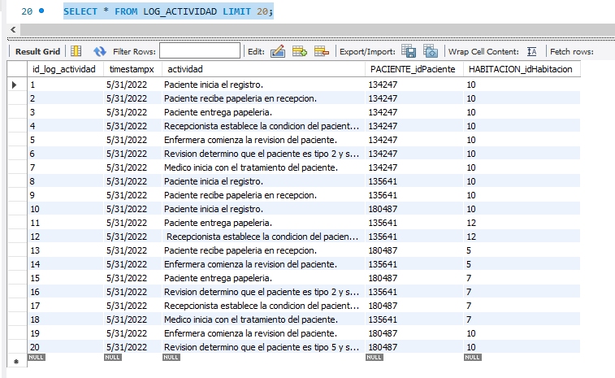

## SELECT * FROM LOG_HABITACION LIMIT 20;

## SELECT * FROM HABITACION LIMIT 20;

## SELECT * FROM PACIENTE LIMIT 20;

## SELECT * FROM LOG_ACTIVIDAD ORDER BY id_log_actividad DESC LIMIT 20;

## SELECT * FROM LOG_HABITACION ORDER BY idLogHabitacion DESC LIMIT 20;

## SELECT * FROM HABITACION ORDER BY idHabitacion DESC LIMIT 20;

## SELECT * FROM PACIENTE ORDER BY idPaciente DESC LIMIT 20;

## SELECT count(*) FROM LOG_ACTIVIDAD;

## SELECT count(*) FROM LOG_HABITACION;

## SELECT count(*) FROM HABITACION;

## SELECT count(*) FROM PACIENTE;

# Dia 5.

## Backup incremental.



## Full Backup.



## SELECT * FROM LOG_ACTIVIDAD LIMIT 20;

## SELECT * FROM LOG_HABITACION LIMIT 20;

## SELECT * FROM HABITACION LIMIT 20;

## SELECT * FROM PACIENTE LIMIT 20;

## SELECT * FROM LOG_ACTIVIDAD ORDER BY id_log_actividad DESC LIMIT 20;

## SELECT * FROM LOG_HABITACION ORDER BY idLogHabitacion DESC LIMIT 20;

## SELECT * FROM HABITACION ORDER BY idHabitacion DESC LIMIT 20;

## SELECT * FROM PACIENTE ORDER BY idPaciente DESC LIMIT 20;

## SELECT count(*) FROM LOG_ACTIVIDAD;

## SELECT count(*) FROM LOG_HABITACION;

## SELECT count(*) FROM HABITACION;

## SELECT count(*) FROM PACIENTE;

